SAFE
Sequential Attachment-based Fragment Embedding (SAFE)
SAFE is a novel molecular line notation that represents molecules as an unordered sequence of fragment blocks to improve molecule design using generative models.
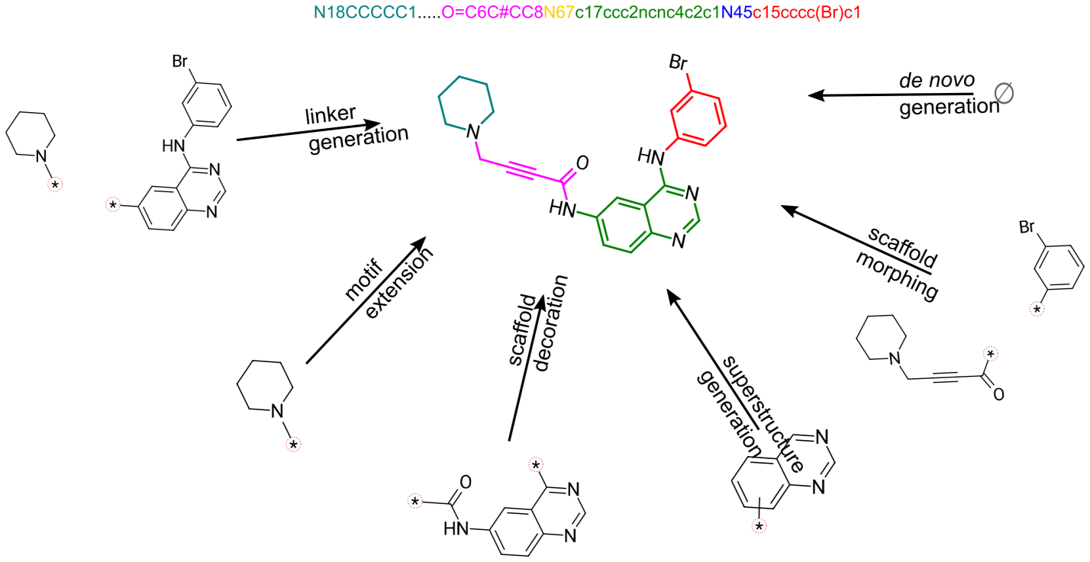

Paper | Docs | Model | Training Dataset

Overview of SAFE
SAFE is the deep learning molecular representation. It's an encoding leveraging a peculiarity in the decoding schemes of SMILES, to allow representation of molecules as a contiguous sequence of connected fragments. SAFE strings are valid SMILES strings, and thus are able to preserve the same amount of information. The intuitive representation of molecules as an ordered sequence of connected fragments greatly simplifies the following tasks often encountered in molecular design:
- de novo design
- superstructure generation
- scaffold decoration
- motif extension
- linker generation
- scaffold morphing
The construction of a SAFE string requires defining a molecular fragmentation algorithm. By default, we use BRICS, but any other fragmentation algorithm can be used.

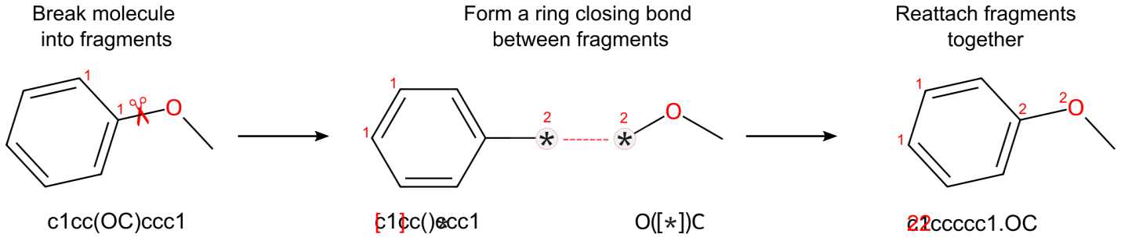

News
2024/01/15
[@IanAWatson] has a C++ implementation of SAFE in LillyMol that is quite fast and uses a custom fragmentation algorithm.

Installation
You can install safe using pip:
pip install safe-mol
You can use conda/mamba:
mamba install -c conda-forge safe-mol
2024/11/22
NOTE: Installation might cause issues like no detection of GPUs (which can be checked by torch.cuda.is_available()) and segmentation error due to mismatch between installed and driver cuda versions. In that case, follow these steps:
conda create -n env_safe python=3.12
conda activate env_safe
Check nvidia driver version on machine by running nvcc --version or nvidia-smi commands
Install pytorch with compatible cuda versions and safe-mol:
conda install pytorch torchvision torchaudio pytorch-cuda=12.1 -c pytorch -c nvidia
conda install -c conda-forge safe-mol

Datasets and Models
Type | Name | Infos | Size | Comment
Model | datamol-io/safe-gpt | 87M params | 350M | Default model
Training Dataset | datamol-io/safe-gpt | 1.1B rows | 250GB | Training dataset
Drug Benchmark Dataset | datamol-io/safe-drugs | 26 rows | 20 kB | Benchmarking dataset

Usage
Please refer to the documentation (https://safe-docs.datamol.io/), which contains tutorials for getting started with safe and detailed descriptions of the functions provided, as well as an example of how to get started with SAFE-GPT.

API
We summarize some key functions provided by the safe package below.
Function | Description
safe.encode | Translates a SMILES string into its corresponding SAFE string.
safe.decode | Translates a SAFE string into its corresponding SMILES string. The SAFE decoder just augment RDKit's Chem.MolFromSmiles with an optional correction argument to take care of missing hydrogen bonds.
safe.split | Tokenizes a SAFE string to build a generative model.

Examples

Translation between SAFE and SMILES representations
import safe

ibuprofen = "CC(Cc1ccc(cc1)C(C(=O)O)C)C"

# SMILES -> SAFE -> SMILES translation
try:
ibuprofen_sf = safe.encode(ibuprofen) # c12ccc3cc1.C3(C)C(=O)O.CC(C)C2
ibuprofen_smi = safe.decode(ibuprofen_sf, canonical=True) # CC(C)Cc1ccc(C(C)C(=O)O)cc1
except safe.EncoderError:
pass
except safe.DecoderError:
pass

ibuprofen_tokens = list(safe.split(ibuprofen_sf))

Training/Finetuning a (new) model
A command line interface is available to train a new model, please run safe-train --help. You can also provide an existing checkpoint to continue training or finetune on your own dataset.
For example:
safe-train --config <path to config> \
--model-path <path to model> \
--tokenizer <path to tokenizer> \
--dataset <path to dataset> \
--num_labels 9 \
--torch_compile True \
--optim "adamw_torch" \
--learning_rate 1e-5 \
--prop_loss_coeff 1e-3 \
--gradient_accumulation_steps 1 \
--output_dir "<path to outputdir>" \
--max_steps 5

References
If you use this repository, please cite the following related paper:
Emmanuel Noutahi, Cristian Gabellini, Michael Craig, Jonathan S. C Lim, Prudencio Tossou. "Gotta be SAFE: A New Framework for Molecular Design." arXiv:2310.10773.

@misc{noutahi2023gotta,
title={Gotta be SAFE: A New Framework for Molecular Design},
author={Emmanuel Noutahi and Cristian Gabellini and Michael Craig and Jonathan S. C Lim and Prudencio Tossou},
year={2023},
eprint={2310.10773},
archivePrefix={arXiv},
primaryClass={cs.LG}
}

License
The training dataset is licensed under CC BY 4.0. This code base is licensed under the Apache-2.0 license. Note that the model weights of SAFE-GPT are exclusively licensed for research purposes (CC BY-NC 4.0).

Development lifecycle

Setup dev environment
mamba create -n safe -f env.yml
mamba activate safe
pip install --no-deps -e .

Tests
You can run tests locally with:
pytest

